**Concept Document**

**Bulls & Cows**

**(The Hacker)**

**Targeted Audience**

The game is suitable for both young teenagers and young grown-ups. From the age group 12 – 20 years old.

**What is the original application Bulls & Cows?**

It is a is a logical, fun and interactive game. Semi-popular game, but still very interactive and logical. This will be one of the first implementations in iOS. It defiantly a nice game to play with friend and family.

**The Persona**

The person is a teenager who want to have fun in every possible situation at any time (at school or at the park). Like at school or outside. The game is look cooler on the phone because of its graphical design and possible some sound effect features will be included. This will make the game to be preferred over plain pen and paper. This person is in a competitive environment, people of the same age. Which struggle to show how good they are at doing thing. That’s why the game give the opportunity to compete agents each other. There can be ranking systems or statistics with their rates of wining or winning against friends, score, how many bull and how many cows in total have they found and achievements.

**What is the game about and why is it called Bulls & Cows**

**The Main Idea**

The game is simple in practice. This is a two-people game, the game is in rounds. Every person in the beginning must pick a 4-digit number with no repeats from 0-9 as their main number. The opponents mustn’t know their opponent’s main number. First player 1 makes up a new 4-digit number with no repeats from 0-9 as a guess and tells it to player 2, then player 2 replace with cows or bulls or nothing (if there are no cows or bulls). Then player 2 does the same. The process is repeated until one of the opponents guesses the main-number of his opponent.

**How it works**

After choosing the main-number, player 1 must start first by entering another 4-digit number from 0-9 whit no repeats. If the entered 4-digit number of Player 1 contains, but it’s not in the same position, one digit form the main-number of Player 2 then player 2 replies with one cow. Example 1. Read. Otherwise if the digit is in the same position Player 2 replies with one bull. There can be more than one cow or bull/ or even cow(s) and bull(s) in a guess. The cows and bulls are used for notification upon which the players experiment with numbers to guess their opponents number (to get 4 bulls). The game is

Example 1: Player 1 enters 1234, but player 2 main-number is 4567. Player 2 says to Player 1 that he has 1 cow

Example 2: Player 1 enters 1234, but player 2 main-number is 7654. Player 2 says to Player 1 that he has 1 bull

**What is the current prototype idea (Bulls & Cows):**

When the application starts there will be three tabs: the first with the game’s layout, two buttons Create and Join game, along with two text fields one for the name with labels and for the 4-digit number. As for the second tab there will be a rule book of the game with simple explanation on how the game works. Finally, the third tab will show the statics and achievement of the player.

When the player clicks create game he will enter the main game layout with where he will have to enter his suggestion after being indicated the other player has entered in the text view. Because this game is round based with rules the other player will be forced to be in stand-by mode until the other player has finished or the timer has expired.

When joining a game, the player enters a table view showing online or offline statuses of game if its full it’s offline else it is online and the name of the group. When clicked on selected row the player enters the game.

**What makes this game different from the original paper & pen:**

If there are interpretations of this game they are purely single player thus not that interesting, while this game has the opportunity to play against friends.

* **Graphics = Interactive**

Because this game typically is played with pen and paper, not at every time it is possible to carry some. Although they are at school, the smart phones are better, simply because you never go anywhere without your phone, it is guaranteed you will use it. Furthermore, there are graphical images that will be displayed to break the with black barrier which the pen and paper provide.

* **Handy = Intuitive**

Another reason why this person is going to use the phone is because it’s handier than write on. Example you cannot write on ground of the park if the persona decides to player with their friend in the outdoors.

* **Competitive = Interest**

The possibility to play with a friend in multiplayer, to compete with him\her to see who is better at it. This is the point of the game to compete and have fun with.

**Extension of the Idea (The Hacker)**

The game will be with more gamification and story; the name of the game will be changed to The Hacker, where you do your normal day to day hacking routing, but you get compromised by other hackers.

Idea extension:

The main changes are you now are a hacker who begins a hacking session, but you get compromised as the hacking session is not secure and you are subjected to attack form other hackers. The 4-digit number represents the hackers unencrypted location. Whoever hacks the other player (cracks the numbers) can write him a challenge, which he must do. So his data is not exploited :D.

To make the game more interactive the competitiveness can be increased drastically by making challenge mode in the game were the game forces you to win to a certain number of rounds. The player how has cracked the most numbers wins. In addition, the app will give the opportunity to see the stats of the other nearby players connected on the same WI-FI. This will give the freedom to the player to choose with whom they will compete.

Visual & Sound Extensions: The rule book will be more interactive with a rule book with a video. Instead of bull and cows there will be cracked and found digits. The them will be dark with green numbers text representing a terminal (console). To deliver the feeling of hacking. The sound which will play will be of type mystery and evil hacked sounds.

Single player with which is going to be the challenge mode where the player has to guess the number before reaching round 8, or he will be automatically hacked by his own phone. The phone will laugh at the player (a sound will be played).

A timer will be added to both single and multiplayer, for every player. If the player doesn’t play a number whit in 20 seconds the player gets 0 numbers found and the other player/ computer plays.

The sound will be able to be turn off.

The stuff which the current bulls and cows has will be extended and modified to appear as the hack game and of course extended with the new features.

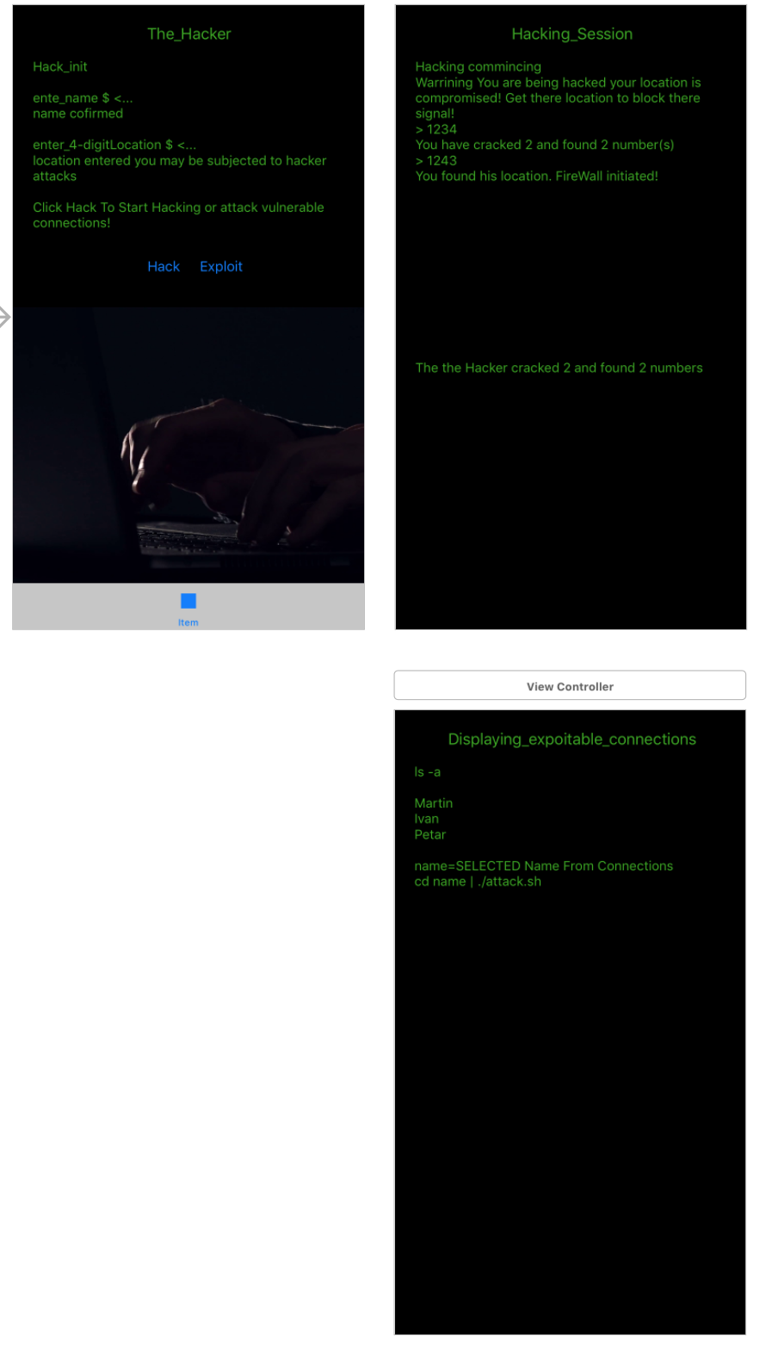

New **simple** design

**MOSCOW TABLE**

|  |  |  |  |  |
| --- | --- | --- | --- | --- |
| Functionality | must | should | could | wont |
| Multiplayer | X |  |  |  |
| Single player |  |  | X |  |
| Graphics (Game view) |  |  |  | X |
| Statistics |  |  | X |  |
| Databases |  |  | X |  |
| Socketing | X |  |  |  |

**Scenarios**

Use case 1: How to Crete a game

Pre-action: The application has been started & Internet connected

MSS:

1. Actor Enters his nickname and 4-digit number with no repeats and clicks on Create Game button
2. Application enters game and wait for some friend to join
3. Indication of connected friend is displayed

Extensions:

1a) Actor doesn’t enter a name/ number has more than 4-digits/ no number entered   
1b) Actor is being alerted with a message to enter missing information  
Goes back to use case step 1

Use case 2: How to Join a game

Pre-action: The application has been started & Internet connected

MSS:

1. Actor Enters his nickname and 4-digit number with no repeats and clicks on Create Game button
2. Gets table view with current status of created games and game names (the name of the player who created the game)
3. Game starts

Extensions:

1a) Actor doesn’t enter a name/ number has more than 4-digits/ no number entered   
1b) Actor is being alerted with a message to enter missing information  
Goes back to use case step 1

**Prototype Design**

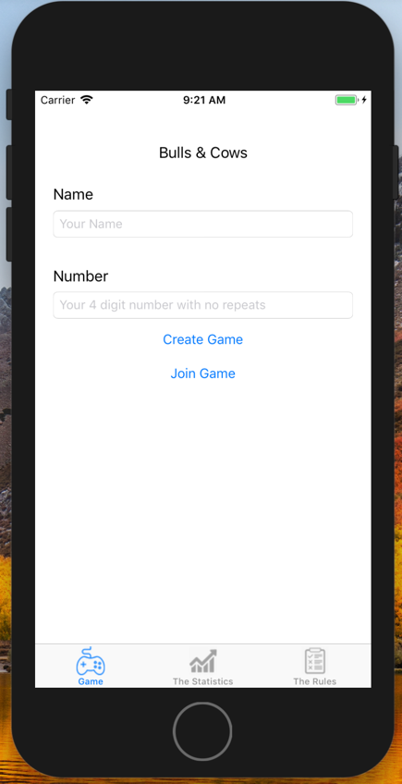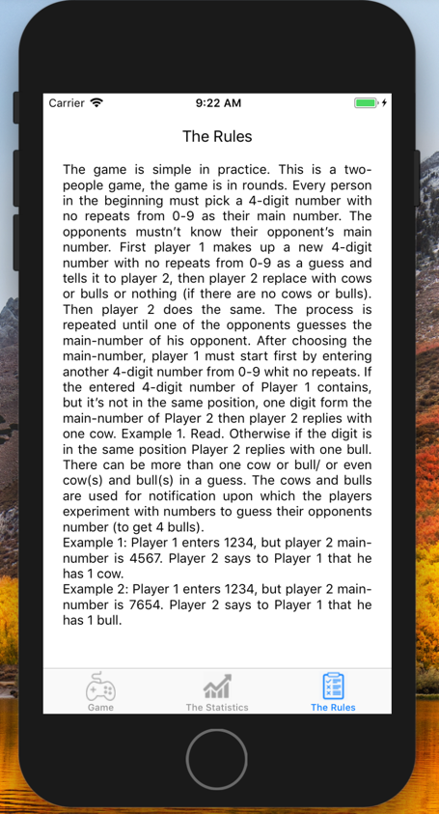

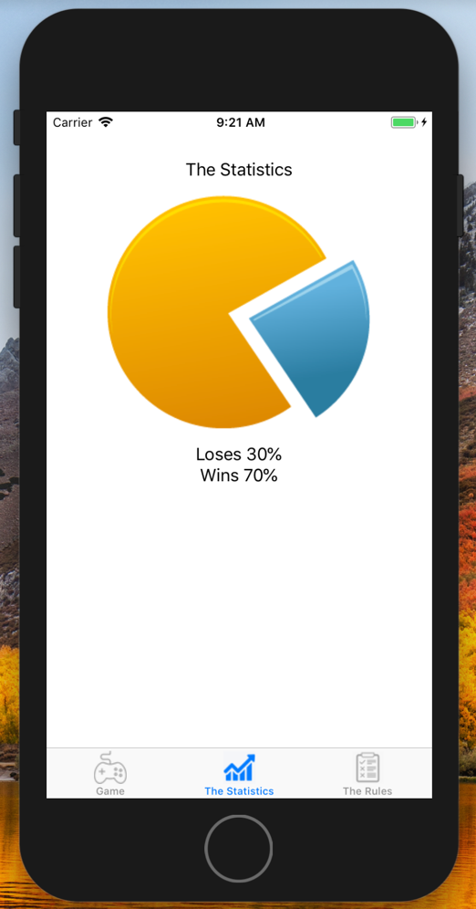

**User Testing**

**Questions**

The questions are related to User experience to see if the program is easy to understand and approach, in addition to gather more information on how and what to improve.

The used equipment to get the user test information is a laptop and notebook.

1. Do you know this game?
2. Do you like hacking?
3. Are the rules well written?
4. Is the content interactive enough?
5. Do you like the achievements in the game?
6. Do you like the visual design of the game? Why? What?
7. Is the game easy to navigate?
8. Is the game easy to play?
9. Is the navigation structured?
10. What effect can be added?
11. What statistics can be added?
12. What do you like about the game?
13. Would you play this game whit a friend or family member?
14. Would you like a single player of the game?
15. What would keep you playing this game?
16. How much time can you wait for the other player to respond?
17. Is challenge mode a good idea for this app?
18. Can you distinguish who’s turn it is?
19. Do you want to keep the score of the other, like knowing how close he is to your number, by seeing his suggestions?

Compilation Feedback from questions:

The game is interactive and easy to use, there is a maximum of three clicks to get to the point. Everything is easy to understand and the idea of hacking and being hacked by others is very cool. Especially, to challenge them to do something cool, if the game is played with a friend. Additionally, it is cool to compete with other players by seeing their stats, so you can see if he is worth the challenge. It’s cool to have a manual and a video to see the process of playing the app and rules. I like the idea of playing it single player with which is going to be the challenge mode where the player has to guess the number before reaching round 8, or he will be automatically hacked by his own phone. The phone will laugh at the player (a sound will be played). The sound may be a problem, because I don’t want to be laugh it is good to turn off the sound in the application itself.

Summary of the results:

The hacking idea has shown more promise than the bulls and cows. The questions still deliver a positive overview of the game, but the time and idea of hacking is wins the bet.